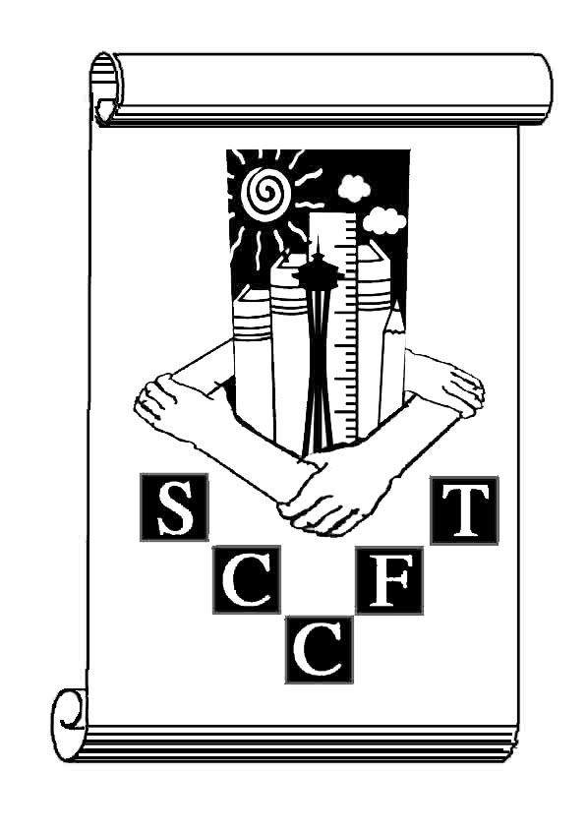
Seattle Community Colleges Federation of Teachers
Union Matters! 2/26/08
Bi-weekly summary of faculty Union happenings
http://wa.aft.org/sccft1789
206-587-5478
What’s happening?

● ALL Faculty Meeting! Friday, March 14
6:00 – 8:30 PM
Seattle Labor Temple
2800 First Avenue

Our Mentor program is taking off! Sign up today to be part of our growing, supportive community of professionals!

Know your rights! Make sure you have a copy of your Agreement!

Know your union officers! Check out their info on our website:
http://wa.aft.org/sccft1789
Grow active along with me! The best is yet to be, the last of the biennium, for which the first was made. *

What a lovely day February 17 was! Faculty flooded the halls of Olympia.

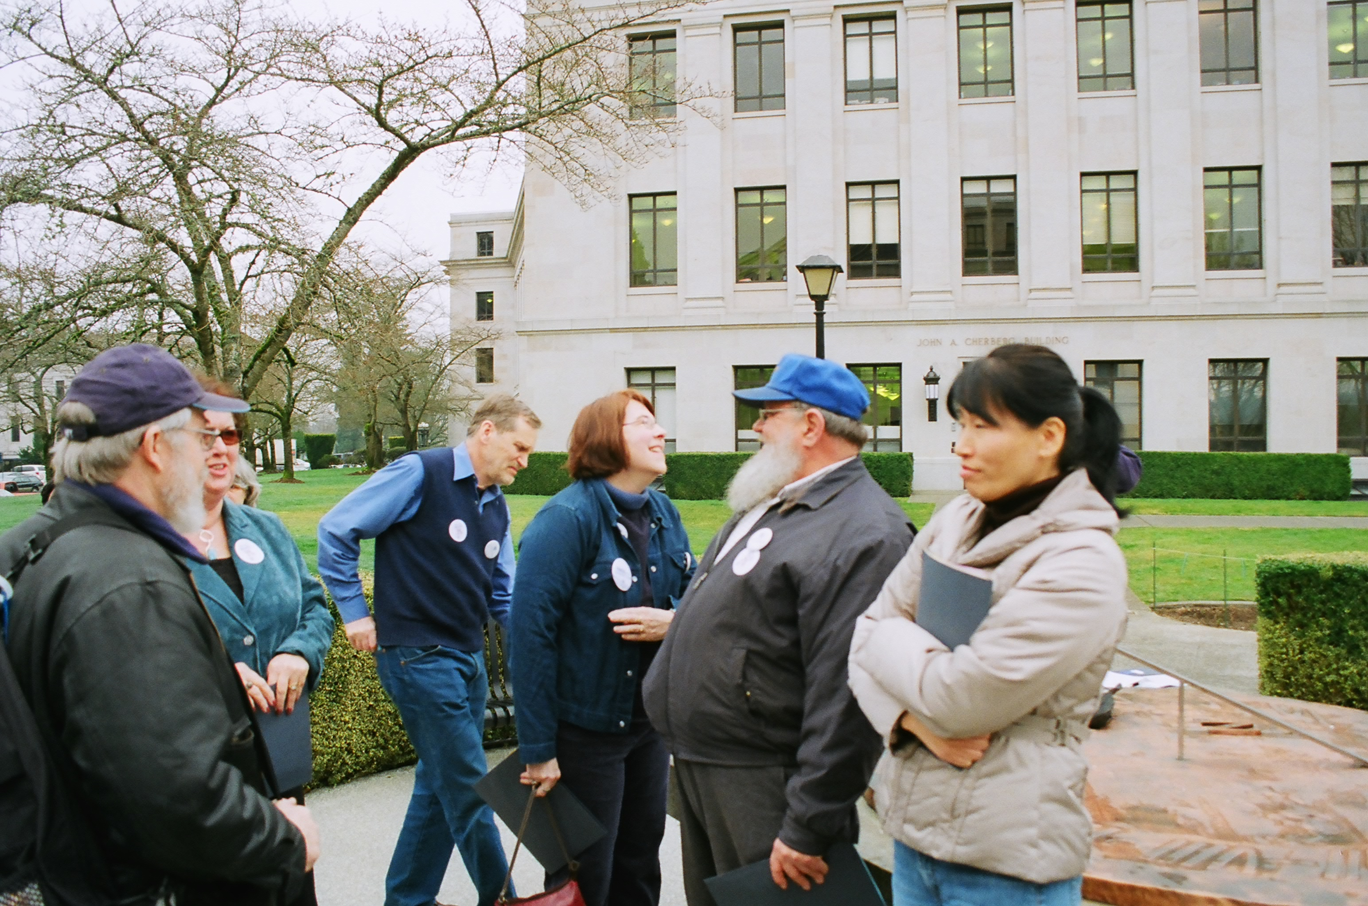

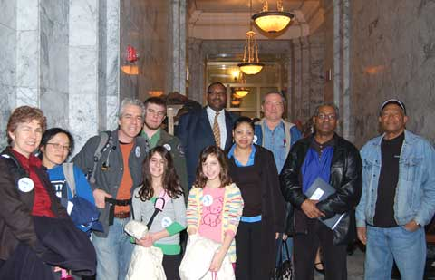

*many thanks (and apologies) to Robert Frost – “Grow old along with me! The best is yet to be, the last of life, for which the first was made.”

We talked with our legislators about FACE, we talked about tuition, we talked about the critical role our community colleges play in our state. Here, Earl and Carol Hamilton, Ed Ciok, Mia Bailey, Dave Eberhardt and Bonnie Flahavan Aghai enjoy a bit of sun between the Cherberg and O’Brien buildings!

Good of the Order…
SCCFT Eboard meets the first and third Tuesdays of the month at the Siegal Center from 3:00-5:00 PM. All Faculty are welcome to attend.

Quote of the Week:

Our mighty 37th District delegation – Bob Markholt (and his son, John), Bennie Johnson, Allen Stowers, Jon Nachman (and his daughters), Tracy Lai, and Karen Strickland pose with Representative Eric Pettigrew -

