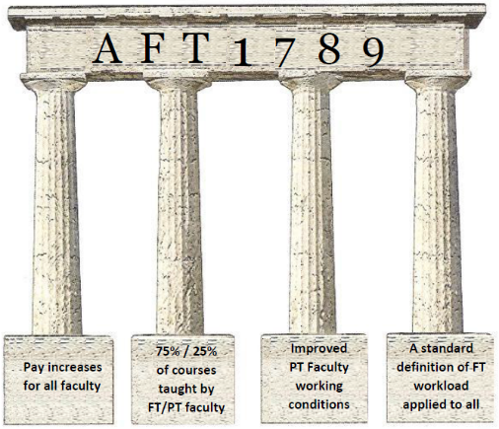
Administrator: ___________________________ Campus__________Dept/Division:_________________
On (date)______________________________________________ I worked __________ hours for no pay.
As a Full Time PHL Part Time faculty member, I do this work because ______________________________
________________________________________________________________________________________
_______________________________________________________________________________________.
U O Me: $______________________________________________________________________________.

Administrator: ___________________________ Campus__________Dept/Division:_________________
On (date)______________________________________________ I worked __________ hours for no pay.
As a Full Time PHL Part Time faculty member, I do this work because ______________________________
________________________________________________________________________________________
_______________________________________________________________________________________.
U O Me: $______________________________________________________________________________.

Administrator: ___________________________ Campus__________Dept/Division:_________________
On (date)______________________________________________ I worked __________ hours for no pay.
As a Full Time PHL Part Time faculty member, I do this work because ______________________________
________________________________________________________________________________________
_______________________________________________________________________________________.
U O Me: $______________________________________________________________________________.

