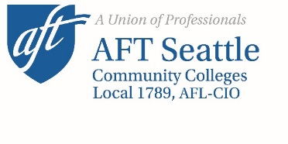
January 5, 2022

To: Chancellor Shouan Pan
The Chancellor’s Executive Cabinet: Dr. Rosie Rimando-Chareunsap, Dr. Chemene Crawford, Dr. Yoshiko Harden, Dr. Kurt Buttleman, Jennifer Dixon, Tereence Hsiao, Dr. Cindy Riche, Kerry Howell, Malcolm Grothe, Earnest Phillips, Steve Leahy, and Kathie Kwilinski
The SCD Board of Trustees: Chair Louise Chernin, Vice-chair Rosa Peralta, Teresita Batayola, Steve Hill, and Brian Surratt

From: The AFT Seattle Local 1789 Executive Board: Annette Stofer, Natalie Simmons, Althea Lazzaro, Marla Robinson, Cristobal Borges, David Krull, Sharon Spence-Wilcox, Alyssa Jocson-Porter, Alecia Spooner, Libby Schoene, Tish Lopez, Charlotte Skeffington, Ruben Murcia, John Toutonghi, Jim Jewell, Jamie Wilson, Helena Ribeiro, and Mia Bailey

Cc: SCD Faculty, Cody Hiatt for AFT SPS, Johnny Dwyer for WFSE

Re: Statement of No Confidence

After attempting to renegotiate safer conditions for faculty and students, as well as our colleges' staff and community, the AFT Seattle 1789 Executive Board hereby declares no confidence in the Chancellor, the Chancellor’s Executive Cabinet, and the Board of Trustees for the Seattle Colleges due to their decision to start Winter Quarter 2022 without new safety measures accounting for the surging Omicron variant of the Covid-19 virus. We support faculty’s call for a vote of no- confidence in District leadership and will work in collaboration with our membership to carry out this vote.

